Identifying Primary Key

Given Table

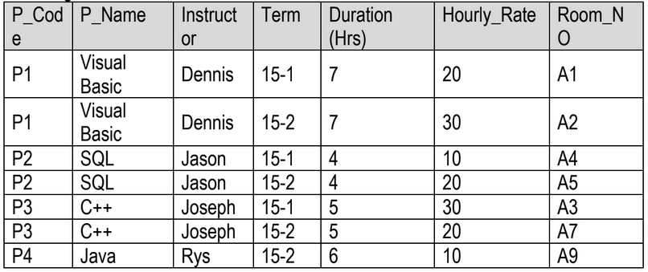

What is Primary Key?

Primary Key is the field/attribute which uniquely identifies a specific row in the table. Primary Key must be unique, not null, and never changing.

In the above table, Room_NO is the primary key, as it has got all the cells unique. Whereas other attributes/fields have values which are repeating, hence they cannot act as a primary key.